**ITS290F Human Computer Interaction & User Experience Design**

**Lab 9. Java Script ES6**

What you’ll learn in this lab:

* Java Script ES6

**1. Readings**

Suggested reference readings

1. JavaScript ES6: 5 new abstractions to improve your code

<https://blog.logrocket.com/javascript-es6-5-new-abstractions-to-improve-your-code-54a369e82407>

1. ES6 In Depth: Rest parameters and defaults

<https://hacks.mozilla.org/2015/05/es6-in-depth-rest-parameters-and-defaults/>

**2. Lab Exercises**

In this tutorial, we will work on the coding with the ES6 Java scripts (JS). To display intermediate information in a webpage, we used to use an UI element as a medium. This time we will learn to display information on the console window of a web browser. For Google Chrome, we can enable this option with the hotkeys **Ctrl + Shirt + I** (or select **Menu (⁝)** 🡪 **More tools** 🡪 **Developer tools**). Console window is also available on other browsers. You may search for the ways to open it on your own.

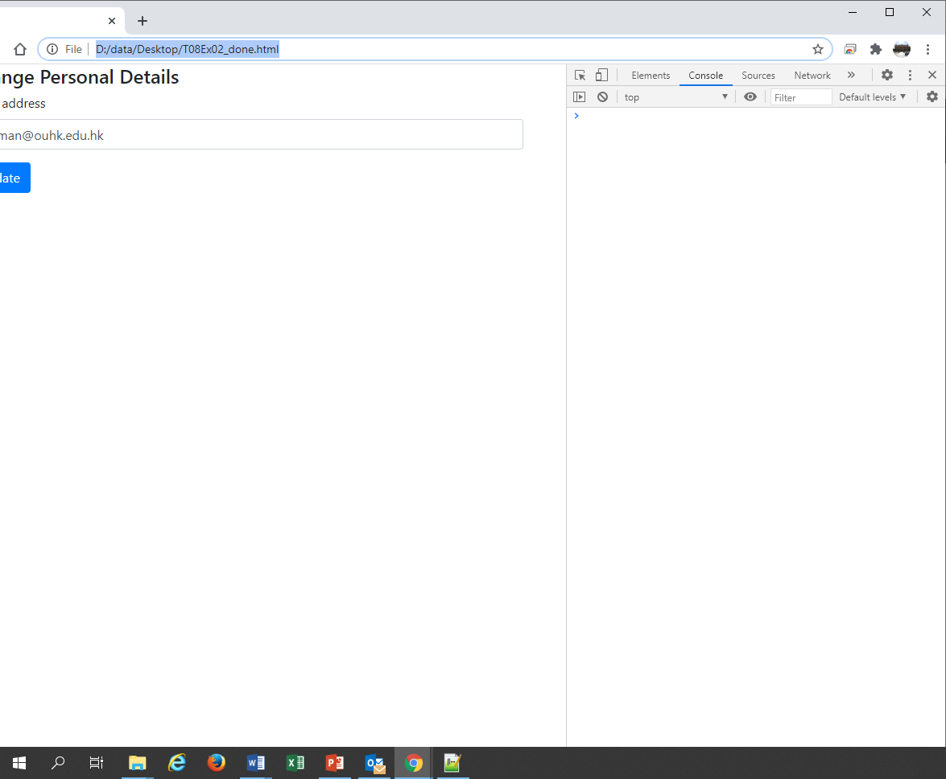

*Console window*

*The console window of Google Chrome*

**Exercise 1**

Open the **T09Ex01.html** file with a text editor and study the code. It has a “Run Script” button on the page, which would trigger the runScript() function when clicked.

Open the page with Google Chrome and open a console window for that page. Click on the “Run Script” button and observe the output on the console window.

|  |
| --- |
| 1. What is the output message displayed on the console window? |
| The console output message...  Hello |

The variable type of greeting1 is declared as a var, where the scope allows the variable can be redeclared inside the if(...) block. Now try to change the two instances of var to let. Save the file and refresh (F5) the page on the browser. Click on the “Run Script” button again and observe the output on the console window.

|  |
| --- |
| 1. What is the output message displayed on the console window? |
| The console output message...  Hey hi |

|  |
| --- |
| 1. According to the trial result of the two different variable types, which of the following statement is true?    1. var can be used to declare constant variables.    2. let can be used to declare global variables.    3. var can be used to declare global variables.    4. let can be used to declare constant variables. |
| Your choice…  C |

**Exercise 2**

Open the **T09Ex02.html** file with a text editor and study the code. There are three constant variables inside the runScript() function, which store the scores of three subjects, i.e. Chinese, English, and Mathematics. It also has an incomplete console.log() statement that intended to print out the average score on the console window.

Complete the console.log() statement so that it can print out the average score with precision of one decimal place. The console output should look like the follows:

The average score is 80.7

Do computation within the console.log() statement and do not change other parts of the script. **Hints**: Refer to the example in page 8 of the JavaScript ES6 slides.

|  |
| --- |
| 1. Paste the completed the console.log() statement here: |
| console.log(`The average score is ${(chi + eng + math) / 3}`); |

**Exercise 3**

Open the **T09Ex03.html** file with a text editor and study the code. There is a var array called districts inside the runScript() function, which holds the districts in Hong Kong. It also has a for loop that iterates over the districts and print them out on the console screen one-by-one.

Update the console.log() statement so that it can also print out the number of characters of each district name. The console output should look like the follows:

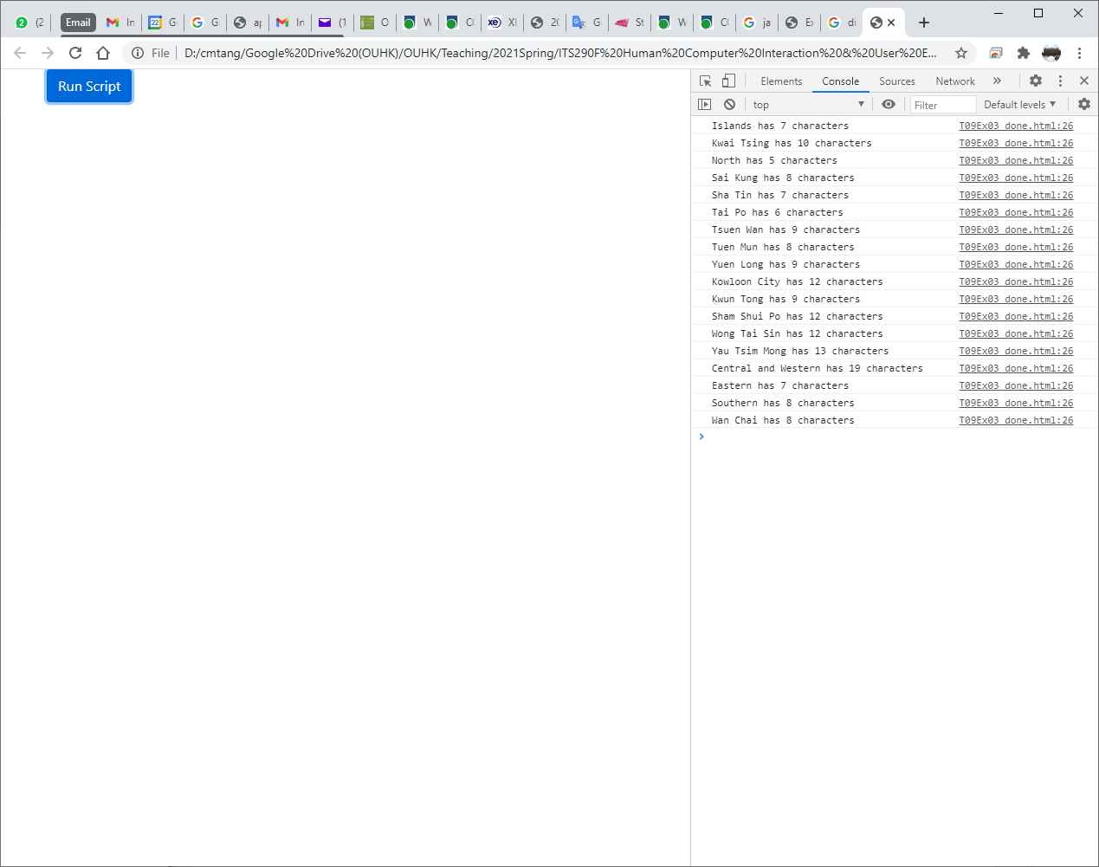

|  |
| --- |
| 1. Paste the completed the console.log() statement here: |
| console.log(`${d} has ${d.length} characters`); |

**Hints**: Using *object*.length to access the length property of an object.

**Submission**

You will get 0 to 3% of OCAS score upon completing the lab exercises.

1. Put your solution code inside the answer boxes and save the file.
2. Upload this file via the corresponding submission link on OLE.

**Note:**

1. The submission deadline is 23:59 of the forthcoming Thursday. The submission link will be closed after the deadline.
2. We mainly focus on the correctness and quality when grading your work.
3. Make sure you submitted a correct file. You can resubmit your work before the deadline.

1. DO NOT modify the layout and format of this document, and DO NOT save it as other file formats, i.e., PDF. Your work will be extracted using an automated document parsing tools for grading.

--- End ---